1. INTRODUCTION

This project will analyze life expectancy data by looking at factors such as immunizations, mortality, finances, social factors, and other health-related issues. It will make it easier for a country to identify the predicting factor contributing to a lower life expectancy value. This will also aid in recommending to a country which areas should be prioritized to effectively raise the population's life expectancy.

We are using the life expectancy dataset by WHO on Kaggle for Life Expectancy Data Analysis. Power BI visualization types such as Gauge Charts, Pie Charts, Line Charts, and Point Maps can be used for the overview page, while Tornado Charts, Doughnut Charts, Treemaps can be used for depicting country-wise data, etc.

**1.1 PROBLEM STATEMENT:**

There is a lot to explore, if the user is interested. The GHO server alone has over 2000 "indicators".

* How are the GHO and UNESCO life expectancies calculated, and what is causing the difference? That could also be asked for Gross National Income (GNI) and mortality features.
* How does the life expectancy after age 60 compare to the life expectancy at birth? Is the relationship with the features in this data set different for those two targets?
* What other indicators on the servers might be interesting to use? Some of the GHO indicators are different studies with different coverage. Can they be combined to make a more useful and robust data feature?
* Unraveling the correlations between the features would take significant work.

**1.2 OBJECTIVES:**

The objective of the project is to analysis project, factors like immunizations, mortality, finances, social issues, and other health-related issues for life expectancy.This will allow countries to determine the predicting factor impacting a lower life expectancy. It will also be useful in helping a country determine which areas should be prioritized to increase life expectancy. For this project, we have utilize the WHO [life expectancy dataset](https://www.kaggle.com/kumarajarshi/life-expectancy-who).

**1.3 SCOPE:**

This project will analyze life expectancy data by looking at factors such as immunizations, mortality, finances, social factors, and other health-related issues. It will make it easier for a country to identify the predicting factor contributing to a lower life expectancy value. This will also aid in recommending to a country which areas should be prioritized to effectively raise the population's life expectancy.

**2. POWER BI DESKTOP AND POWER BI ONLINE – WHAT IS IT?**

Power BI is a programme for data analysis and report design linked to a set of online services, including publishing and sharing.

Within the Power BI application environment, we can distinguish between:

– Power BI desktop – a free application that runs on Windows PCs, allowing you to connect to data, build a report and save to file, as well as publish the report to the Power BI Online service.

– Power BI online – a report server accessible via a browser and app on mobile devices. It combines the functionality of Power BI Desktop (but without the ability to save the file to a computer) with the ability to share generated reports.

**2.1 CONTEXT**

we are developing our data science skills in areas of data analysis. An interesting problem for us was to identify which factors influence life expectancy on a national level. There is an existing Kaggle data set that explored this, but that information was corrupted. Part of the problem solving process is to step back periodically and ask "does this make sense?" Without reasonable data, it is harder to notice mistakes in my analysis code (as opposed to unusual behavior due to the data itself). we wanted to use a similar data set, but with reliable information.

This is our first time exploring life expectancy, so we had to guess which features might be of interest when making the data set. Some were included for comparison with the other Kaggle data set. A number of potentially interesting features (like air pollution) were left off due to limited year or country coverage. Since the data was collected from more than one server, some features are present more than once, to explore the differences.

**3. Gartner Analytics and BI Virtual Bake-Off 2020: world population health analysis with Power BI**

The concept of the bake-off is very straight forward. Vendors are asked to use a consistent data set to facilitate a side-by-side comparison. Gartner tries to pick data sets that also allow participants to showcase how the data and analytics community can do good with data.

Here are some insights and highlights from the report:

* Just 200 years ago, worldwide life expectancy was in the early 30’s. By 1960 life expectancy jumped to the 50’s but masked global health inequalities. Today, life expectancy is in the 70’s with large improvements taking place in the developing world in the last couple of decades.
* Child mortality rates have reduced significantly in the last 30 years. Countries that saw a 1 in 3 child mortality rate 30 years ago have reduced it to about 1 in 10.
* One of the most important socio-economic factors associated with higher life expectancy is having access to safe drinking water. If we focus the analysis the female population, having access to education is an important life expectancy driver.
* Asia saw the largest growth in life expectancy in the last decade (over 6% growth). This growth was particularly high in countries that saw significant decreases in maternal mortality during this time.

## 3.1 PROPOSED SYSTEM

A key metric for measuring population health is life expectancy. It is beneficial to analyze life expectancy data when considering the health of a population, its characteristics, and when studying human diseases and natural population fluctuations. This is where power BI comes into play.

## 3.2 POWER BI WORKFLOW

A review of the Power BI workflow.

### When to use

Developing Power BI solutions follows a linear process that eventually comes full circle.  Having said that, you could end up looping back to a previous step at any time to expand the system or correct issues.

### Instructions

The main steps in the development process for a Power BI solution are:

Get & Transform Data

* Power BI can collect data from files, web pages, databases and more
* We have a rich set of transformation tools to clean up the data
* We can refresh any collection and transformations by hitting the Refresh button
* The technology behind the “Get Data” button is also known as “Power Query”

Relate Tables

* Commonly known as ‘Modeling’
* Allows us to create links between tables so that data from multiple tables can be used in a single (or multiple) visual(s)

Develop Measures

* Measures are portable formulas
* They use a formula language called DAX, which is VERY similar to Excel’s formula language for “Power Pivot”

Develop Visuals

* Power BI contains a rich variety of built in visuals configured via a drag and drop interface
* All visuals can be customized to make them look good
* All visuals are interactive and cross filter each other
* Custom visuals can be imported if you need more than the “out of the box” supply

Publish, Explore & Share

* Reports can be published to the web
* We can then build dashboards that can be shared with others
* Reports and dashboards are always as up to date as the latest data uploaded
* Refresh can often be scheduled to happen automatically

**4. METHODOLOGY**

## 4.1 GETTING STARTED WITH POWER BI

* To get started with Desktop Power BI for excel, CSV files will be imported. First, we will click get data, and from that menu, we will select the CSV file and then load the data.
* We can create chart of different types on visualizations. Under the File menu, you can save the file and reopen it .

Model can be created by selecting excel sheets and making a relation with other data.

#### 4.2 TRANSFORMING DATA

Data needs to be formatted according to the need of columns. There are many processing errors which leads to blank rows.

**4.3 QUERY EDITOR**

We will use the Power Query Editor which is a tool that allows you to edit the data before loading it. You can use it to format the data and decide what needs to be load. Power Query is that you need to close and apply the changes to be made to the data in the report. We need to clean the data before loading it. We can here remove or delete the columns on our own choice. You give Power Query Editor step-by-step directions for modifying data while loading and presenting it. The original data source is unaffected by shaping; only this view of the data is affected. Transforming data, or renaming columns, tables, eliminating rows or columns, or altering data types, is an example of shaping.

**4.4 BUILD REPORTS**

* The top of the screen displays common report and visualization functions.
* The middle part is where visualizations are produced and placed.
* The bottom of the page tab section allows you to pick or add report pages.
* You can filter data visualizations in the Filters window.

**5. SYSTEM REQUIREMENTS**

**5.1 SYSTEM AND HARDWARE REQUIREMENTS FOR POWER BI**

Like any software, Power BI also has specific hardware requirements necessary to be installed on a computer. Most commonly, the hardware requirements relate to the supported system, type of processor, sufficient free disk space, amount of RAM and screen resolution.

Below are the system requirements for Power BI – the minimum characteristics of a computer system or hardware necessary to run the programme.

**5.2 SUPPORTED OPERATING SYSTEMS**

The Power BI programme can be installed on any computer with a system listed below:

– Windows Server 2019 Datacenter, Server 2019 Standard, Server 2016 Datacenter, Server 2016 Standard

– Windows 10 Home, 10 Professional, 10 Enterprise and Windows 11

**5.3 WEB BROWSER**

Microsoft Power BI Desktop requires Internet Explorer 11 or later to function.

**5.4 SCREEN RESOLUTION**

The required screen resolution is at least 1440×900 or 1600×900 (16:9). Lower resolutions are not supported.

**5.5 HARD DRIVE**

The Power BI service report server requires a minimum of 1 GB of free hard drive space.

**5.6 MEMORY**

The minimum memory for Power BI is specified as 1 GB, with 4 GB recommended.

5.7 PROCESSOR TYPE

Installation of the Power BI service report server is only possible on x64 processors.

**5.8 PROCESSOR SPEED**

Power Bi’s minimum x64 processor speed is specified as 1.4 GHz, recommended as 2.0 GHz or faster.

Detailed information: https://docs.microsoft.com/pl-pl/power-bi/fundamentals/desktop-get-the-desktop

**6. RESULTS**

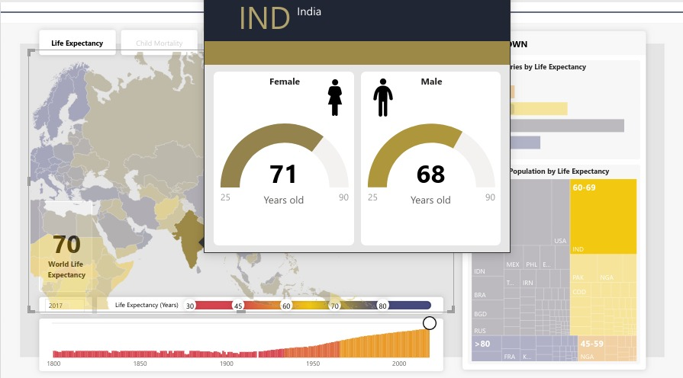

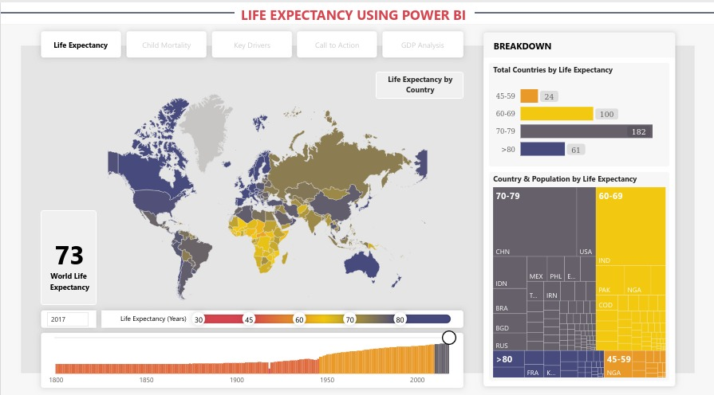

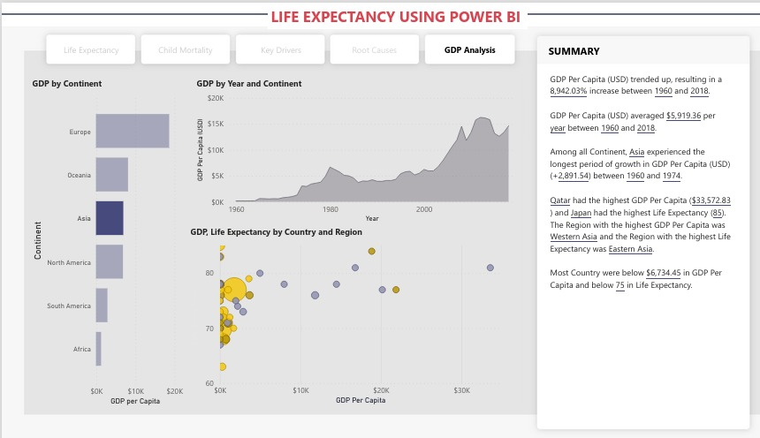

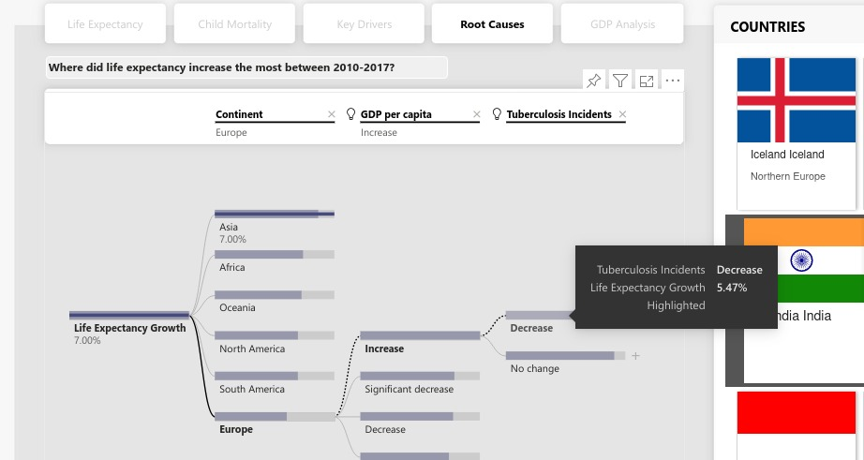

1. **CONCLUSION**

Power BI is one of the most powerful business intelligence tools for analyzing and visualizing data. Throughout this project, we discussed what Power BI is, why it is important, and the Power BI project ideas that we have implemented to improve our data analysis and visualization skills. Power BI project examples generally aid companies in gaining actionable insights from better visualization of their data. Using Power BI, users can create interactive dashboards and share them across the internet. Power BI also allows you to collaborate with other users and stakeholders on separate projects.

These Power BI project ideas has allow us to hone our skills and learn how to truly integrate business intelligence and data science. As we work on these project ideas, we’ve gain a greater understanding of how Power BI can be used for a data-driven approach towards various data science industries.

1. **REFERENCES**

World Health Organization: All Health Indicators (link below for the USA)

<https://data.humdata.org/dataset/who-data-for-united-states-of-america>

World Bank: Combined Indicators (link below for the USA)

<https://data.humdata.org/dataset/world-bank-combined-indicators-for-united-states>

World Population Review: Total Population

<https://worldpopulationreview.com/countries>

Gap Minder: Life expectancy since 1800

<https://www.gapminder.org/data/>

Wikipedia: Flag images

<https://en.wikipedia.org/wiki/Gallery_of_sovereign_state_flags>

Our World in Data: Life expectancy

<https://ourworldindata.org/life-expectancy>

Our World in Data: Why do women live longer than men?

<https://ourworldindata.org/why-do-women-live-longer-than-men>

BBC: Do we really live longer than our ancestors?

<https://www.bbc.com/future/article/20181002-how-long-did-ancient-people-live-life-span-versus-longevity>